Dear Intern

Interim project report is an inherent component of your internship. We are enclosing a reference table of content for the interim project report.

The key objective of this report is for you to capture how far you have got in completing the internship work against milestones expected to be achieved within a specific duration and seek the mentor’s feedback. Depending on the internship project and your progress (IT/Non-IT, Technical/Business Domain), you may choose to include or exclude or rename sections or leave some sections blank from the table of content mentioned below. You can also add additional sections. You can refer the project presentation to view the milestones related to your internship project. Please populate milestone# (1 / 2 / 3) and the milestone description in the interim project report based on the milestone for which you are submitting the interim project report.

You can refer the project presentation to view the milestones related to your internship project.

|  |  |
| --- | --- |
| Internship Project Title | RIO-125: Forecasting System - Project Demand of Products at a Retail Outlet Based on Historical Data |
| Name of the Company | TCS iON |
| Name of the Industry Mentor | Debashis Roy |
| Name of the Institute | ICT Academy of Kerala |

|  |  |  |  |  |  |  |
| --- | --- | --- | --- | --- | --- | --- |
| Start Date | End Date | | Total Effort (hrs.) | | Project Environment | Tools used |
| 5/02/2023 | 09/02/2023 | | 20 | | Jupyter Notebook | Python |
| Milestone # | 1 | Milestone: | | Interim Project Report - 1 | | |

**TABLE OF CONTENT**

* Acknowledgements
* Objective
* Introduction / Description of Internship
* Internship Activities
* Approach / Methodology
* Assumptions
* Exceptions / Exclusions
* Charts, Table, Diagrams
* Algorithms
* Challenges & Opportunities
* Risk Vs Reward
* Reflections on the Internship
* Recommendations
* Outcome / Conclusion
* Enhancement Scope
* Link to code and executable file
* Research questions and responses

**ACKNOWLEDGEMENT**

“I would like to express our deep appreciation to all those who have contributed to the successful completion of this project.

Special thanks to our project guide from TCS iON for their invaluable guidance and support. Their expertise and assistance was crucial in making this project a reality.

I also extend our appreciation to ICT Academy of Kerala for offering us the opportunity to work with TCS iON as part of a one-month internship program, which allowed me to gain a deeper understanding of the IT industry's work culture.

I would like to acknowledge the support of my colleagues and friends who have provided me with their suggestions and insights, which have been of immense help in completing this project.

Finally, we would like to thank our families for their love, support and encouragement throughout the project.

Thank you, everyone, for your support and cooperation."

Bottom of Form

**OBJECTIVE**

The objective of the project Forecasting System - Project Demand of Products at a Retail Outlet Based on Historical Data is to predict the demand for products at a retail outlet based on historical sales data.

The goal is to create a forecasting model that can accurately predict future product demand, allowing the retail outlet to make informed decisions regarding inventory management, product sourcing, and sales planning.

The project aims to improve the efficiency and profitability of the retail outlet by reducing the instances of stock shortages or overstocking. The project also provides a platform to analyze sales trends and make data-driven decisions to optimize the retail outlet's operations.

**INTRODUCTION**

"The demand forecasting system has become a critical component in managing the supply chain of modern retail businesses. Accurate forecasting of product demand allows retailers to make informed decisions on inventory management, product ordering, and pricing strategies.

The objective of this project is to develop a forecasting system that will predict the demand for products at a retail outlet based on historical data. This system will provide the retail outlet with valuable insights on the future demand for their products, enabling them to make data-driven decisions to optimize their supply chain and increase profitability.

The project focuses on analyzing the historical sales data of the retail outlet to identify patterns and trends that can be used to make accurate demand forecasts. Advanced statistical techniques and machine learning algorithms were employed to build the forecasting model.

This report details the methodology and results of the project, and highlights the potential impact of the forecasting system on the retail outlet's operations and profitability. The report also includes a discussion of the limitations and future directions for improvement of the forecasting system."

**METHODOLOGY**

Common methodologies for time series forecasting in the context of the Forecasting System - Project Demand of Products at a Retail Outlet Based on Historical Data:

* **Naive Method**: This method is based on the assumption that the future will be similar to the past. It simply uses the previous observation as the forecast for the next period.
* **Moving Average Method**: This method calculates the average of the past few observations and uses it as the forecast for the next period.
* **Exponential Smoothing**: This method involves calculating the weighted average of past observations, with more weight given to the more recent observations.
* **ARIMA (AutoRegressive Integrated Moving Average**): This method models the relationship between an observation and a number of lagged observations.
* **SARIMA (Seasonal ARIMA)**: This method is similar to ARIMA, but takes into account seasonality in the data.
* **Prophet:** This is a forecasting method developed by Facebook specifically for time series data. It is based on decomposing the time series into trend, seasonality and holiday components.
* **Neural Networks**: This method uses artificial neural networks to model the relationships in the data and make forecasts.

**EXPLORATORY DATA ANALYSIS**

Inferences obtained from dataset are:

* The training dataset consists of two files, with one containing the target sales column for training and the other used for testing the model.
* The test data includes information from January 1st, 2018 to March 31st, 2018.
* The maximum date in the training set is December 31st, 2017, while the maximum date in the test set is March 31st, 2018.
* The forecast lag size is 90.
* It was determined that during the time period from January 1st, 2013 to December 31st, 2017, the train dataset had 10 stores selling 50 items.
* Information was also gathered on the total sales in each of the 10 stores and the number of the 50 items sold in each store.
* All stores have the same number of unique items.

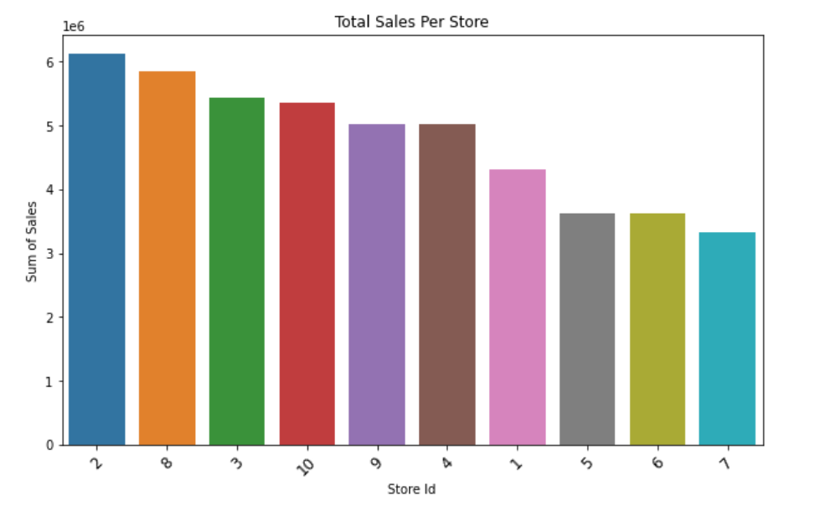

**Figure: Total sales per store**

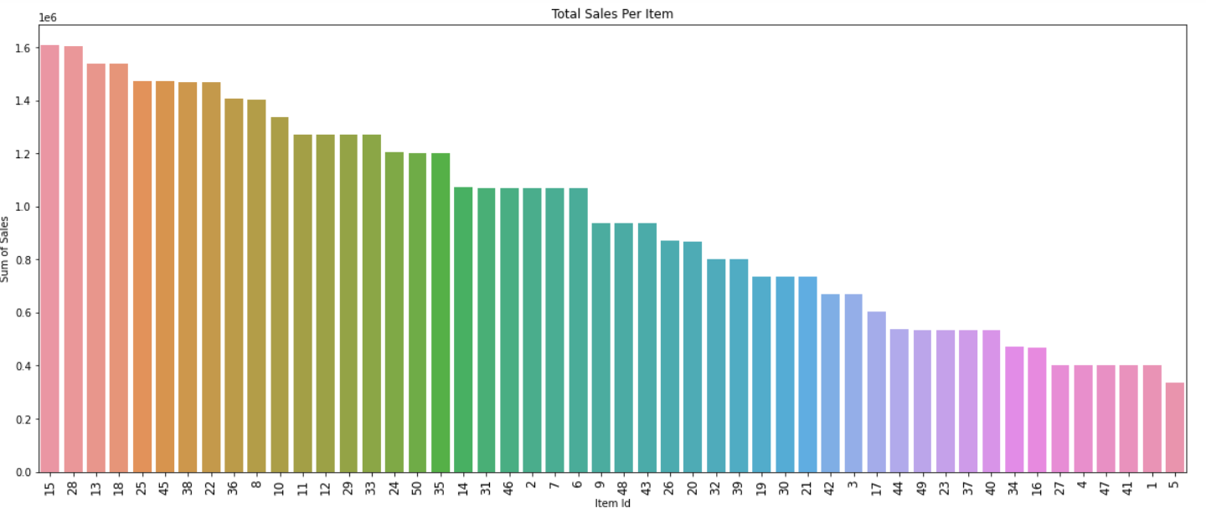

**Figure: Total sales per item**

**CHECKING DATA STATIONARITY**

To check if the data is stationary, create the total daily, monthly and annual sales data frames:

* Daily Sales Data Frame: Aggregate the sales data by day to calculate the total sales for each day. This will provide a daily view of the sales trend.
* Monthly Sales Data Frame: Group the daily sales data by month to calculate the total sales for each month. This will provide a monthly view of the sales trend.
* Annual Sales Data Frame: Group the monthly sales data by year to calculate the total sales for each year. This will provide an annual view of the sales trend.

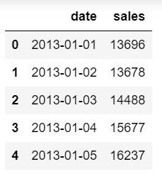 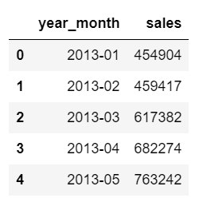 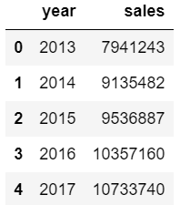

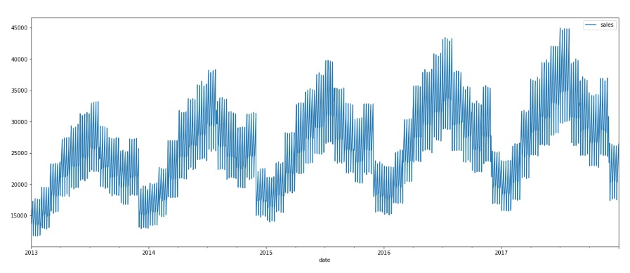

**Figure: Daliy sales from 2013 to 2017**

Data seems not stationary because the average daily sales grow over time when we plot the total daily sales over time.

To make the non-stationary sales data stationary, you can use the difference method, which involves subtracting the value of a specific time step from the value of the previous time step. This helps to remove the trend component from the data and make it stationary.

By calculating the difference between the sales of each month, you can add this difference as a new column to the data frame. This transformed data can then be used to check if it is stationary or not.

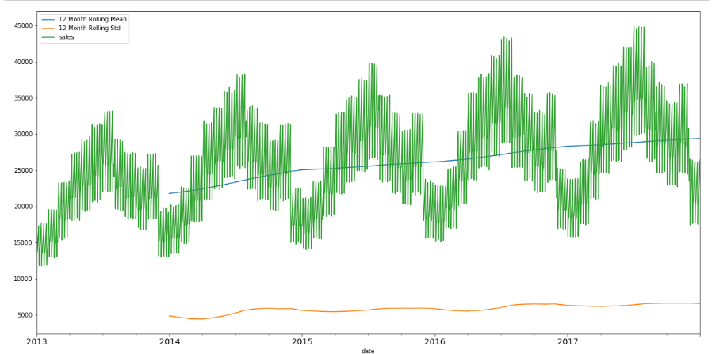

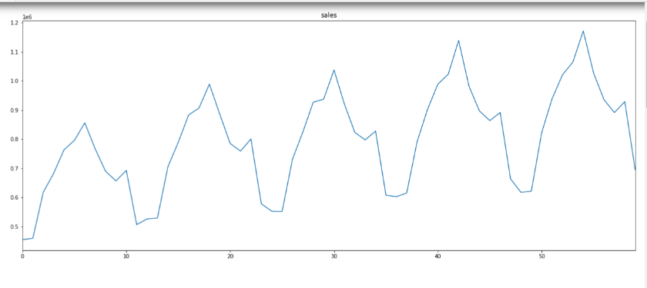

The data is indeed seasonal and follows an upward trend. Also, the average value or the mean of the residuals seem to be zero which holds our assumption.

Assumptions

Exceptions / Exclusions

Charts, Table, Diagrams

Algorithms

Challenges & Opportunities

Risk Vs Reward

Reflections on the Internship

Recommendations

Outcome / Conclusion

Enhancement Scope

Link to code and executable file

Research questions and responses